Cambridge 12 – Test 6 – Writing task 1

**Task 1 (Cambridge 12 Test 6 IELTS Writing)**

**Câu hỏi : The maps below show the centre of a small town called Islip as it is now, and plans for its development. Summarize the information by selecting and reporting the main features, and make comparisons where relevant.**

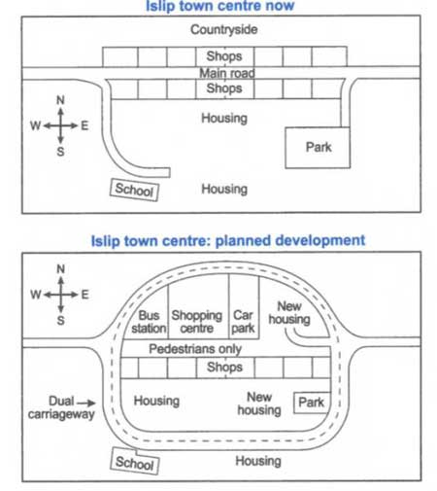

Cách 1

The plans illustrate the layout of a small town named Islip at the present and show how it will change in the future. Overall, the centre of the town will experience a number of developments in infrastructure and facilities, most notably with a dual carriageway and a road for pedestrians being installed.

As far as the road network is concerned, the dual carriageway will be built around the town centre and the current main road will be converted into the street for pedestrians only. Regarding the developments in facilities, the rural area and the row of shops in the north will be demolished to make way for the construction of a big shopping centre with a bus station and a car park being built on the two sides. Moving to the south, the shopping blocks and the school will remain intact. The housing unit behind these shops will be relocated further west, adjacent to the dual carriageway. Besides some residential areas that now is existing, there will be a new one on the right of the car park and another one on the left of the park which will be reduced in size.

Cách 2

The plans illustrate how a small town named Islip looks like now and how it is planned to change in the future. Overall, the centre of the town will experience a number of developments in infrastructure and facilities, most notably with the demolition of the rural area and the addition of a dual carriageway and a road for pedestrians.

Looking at the original layout, the northern tip of the town centre is close to a rural area. There is a main road with two rows of shops on the two sides running through the town from the west to the east. Behind the row of shops in the south is a residential area which is opposite another one in the southern tip of the south. A school is situated at the end of a small path splitting from the western junction. Similarly, where a small road branching out from the eastern junction ends is a large park.

In the future, as far as the road network is concerned, the dual carriageway will be built around the town centre and the current main road will be used for pedestrians only. Regarding the developments in facilities, the rural area and the row of shops in the north will be demolished to make way for the construction of a big shopping centre with a bus station and a car park being built on the two sides. Moving to the south, the shopping blocks and the school will remain intact. The housing unit behind these shops will be relocated further west, adjacent to the dual carriageway. Besides some residential areas that now is existing, there will be a new one on the right of the car park and another one on the left of the park which will be reduced in size.